CODE:
//=====================================================================
// Description: SystemVerilog Assertions for the synchronous FIFO.
// Bound to the fifo module so that internal signals
// (wr_ptr, rd_ptr) are directly visible without
// modifying the RTL port list.
//=====================================================================
module fifo_assertions #(
parameter int DATA_WIDTH = 8,
parameter int DEPTH = 8,
parameter int PTR_WIDTH = $clog2(DEPTH)
)(
input logic clk,
input logic rst_n,
input logic wr_en,
input logic rd_en,
input logic [DATA_WIDTH-1:0] din,
input logic [DATA_WIDTH-1:0] dout,
input logic full,
input logic empty,
input logic [PTR_WIDTH:0] wr_ptr,
input logic [PTR_WIDTH:0] rd_ptr
);

//=================================================================
// Reference model (golden queue) for data-ordering checks
//=================================================================
logic [DATA_WIDTH-1:0] ref_q[$];
logic [DATA_WIDTH-1:0] expected_data;
logic expected_valid;

always_ff @(posedge clk or negedge rst_n) begin
if (!rst_n) begin
ref_q.delete();
expected_data <= '0;
expected_valid <= 1'b0;
end else begin
// Model a valid write
if (wr_en && !full) ref_q.push_back(din);

// Model a valid read (dout is registered, valid 1 cycle later)
if (rd_en && !empty) begin
expected_data <= ref_q.pop_front();
expected_valid <= 1'b1;
end else begin
expected_valid <= 1'b0;
end
end
end

//=================================================================
// Property 1: FIFO shall be empty after reset
//=================================================================
property p_reset_empty;
@(posedge clk) $rose(rst_n) |-> empty;
endproperty
a_reset_empty: assert property (p_reset_empty)
else $error("[ASSERT FAIL] FIFO not empty immediately after reset");

//=================================================================
// Property 2: full and empty shall not be asserted simultaneously
//=================================================================
property p_full_empty_mutex;
@(posedge clk) disable iff (!rst_n) !(full && empty);
endproperty
a_full_empty_mutex: assert property (p_full_empty_mutex)
else $error("[ASSERT FAIL] full and empty asserted at the same time");

//=================================================================
// Property 3: A read shall not be performed when FIFO is empty
// (i.e., an rd_en while empty must have NO effect on rd_ptr)
//=================================================================
property p_illegal_read_ignored;
@(posedge clk) disable iff (!rst_n)
(rd_en && empty) |=> (rd_ptr == $past(rd_ptr));
endproperty
a_illegal_read_ignored: assert property (p_illegal_read_ignored)
else $error("[ASSERT FAIL] rd_ptr changed during illegal read (empty)");

cov_illegal_read: cover property (
@(posedge clk) disable iff (!rst_n) (rd_en && empty));

//=================================================================
// Property 4: A write shall not be performed when FIFO is full
// (i.e., a wr_en while full must have NO effect on wr_ptr)
//=================================================================
property p_illegal_write_ignored;
@(posedge clk) disable iff (!rst_n)
(wr_en && full) |=> (wr_ptr == $past(wr_ptr));
endproperty
a_illegal_write_ignored: assert property (p_illegal_write_ignored)
else $error("[ASSERT FAIL] wr_ptr changed during illegal write (full)");

cov_illegal_write: cover property (
@(posedge clk) disable iff (!rst_n) (wr_en && full));

//=================================================================
// Property 5: A valid write to an empty FIFO shall make it non-empty
//=================================================================
property p_write_empty_to_nonempty;
@(posedge clk) disable iff (!rst_n)
(wr_en && empty && !full) |=> !empty;
endproperty
a_write_empty_to_nonempty: assert property (p_write_empty_to_nonempty)
else $error("[ASSERT FAIL] FIFO still empty after valid write to empty FIFO");

cov_write_empty: cover property (
@(posedge clk) disable iff (!rst_n) (wr_en && empty && !full));

//=================================================================
// Property 6: A valid read from a full FIFO shall make it non-full
//=================================================================
property p_read_full_to_nonfull;
@(posedge clk) disable iff (!rst_n)
(rd_en && full && !empty) |=> !full;
endproperty
a_read_full_to_nonfull: assert property (p_read_full_to_nonfull)
else $error("[ASSERT FAIL] FIFO still full after valid read from full FIFO");

cov_read_full: cover property (
@(posedge clk) disable iff (!rst_n) (rd_en && full && !empty));

//=================================================================
// Property 7: Data shall be read out in FIFO (FIFO) order
//=================================================================
property p_data_order;
@(posedge clk) disable iff (!rst_n)
expected_valid |-> (dout == expected_data);
endproperty
a_data_order: assert property (p_data_order)
else $error("[ASSERT FAIL] Data ordering violation: expected=%0h got=%0h",
expected_data, dout);

//=================================================================
// Additional coverage to help identify vacuous assertion successes
//=================================================================
cov_full_reached : cover property (@(posedge clk) disable iff (!rst_n) full);
cov_empty_reached : cover property (@(posedge clk) disable iff (!rst_n) empty);
cov_valid_write : cover property (@(posedge clk) disable iff (!rst_n) (wr_en && !full));
cov_valid_read : cover property (@(posedge clk) disable iff (!rst_n) (rd_en && !empty));

endmodule

//=====================================================================
// Bind statement: attaches the checker to every instance of "fifo"
// without modifying the RTL. Internal signals wr_ptr/rd_ptr of the
// fifo module are visible here because bind places the instance
// inside the target module's scope.
//=====================================================================

bind fifo fifo_assertions #(
.DATA_WIDTH(DATA_WIDTH),
.DEPTH(DEPTH),
.PTR_WIDTH(PTR_WIDTH)
) u_fifo_assertions (
.clk (clk),
.rst_n (rst_n),
.wr_en (wr_en),
.rd_en (rd_en),
.din (din),
.dout (dout),
.full (full),
.empty (empty),
.wr_ptr (wr_ptr),
.rd_ptr (rd_ptr)
);

//=====================================================================
// Description: Testbench for the synchronous FIFO. Generates clock,
// reset, and directed stimulus covering all required
// test cases. Assertions from fifo_assertions.sv are
// automatically attached via the `bind` statement.
//=====================================================================
module fifo_tb;

localparam int DATA_WIDTH = 8;
localparam int DEPTH = 8;

logic clk;
logic rst_n;
logic wr_en, rd_en;
logic [DATA_WIDTH-1:0] din;
logic [DATA_WIDTH-1:0] dout;
logic full, empty;

int i;

//-----------------------------------------------------------------
// DUT instantiation
//-----------------------------------------------------------------
fifo #(
.DATA_WIDTH(DATA_WIDTH),
.DEPTH (DEPTH)
) dut (
.clk (clk),
.rst_n (rst_n),
.wr_en (wr_en),
.rd_en (rd_en),
.din (din),
.dout (dout),
.full (full),
.empty (empty)
);

//-----------------------------------------------------------------
// Clock generation: 10ns period
//-----------------------------------------------------------------
initial clk = 1'b0;
always #5 clk = ~clk;

//-----------------------------------------------------------------
// Reset generation (active-low)
//-----------------------------------------------------------------
initial begin
rst_n = 1'b0;
wr_en = 1'b0;
rd_en = 1'b0;
din = '0;
repeat (3) @(negedge clk);
rst_n = 1'b1;
end

//-----------------------------------------------------------------
// Tasks for write / read stimulus (single-cycle pulses)
//-----------------------------------------------------------------
task automatic do_write(input [DATA_WIDTH-1:0] data);
@(negedge clk);
wr_en = 1'b1;
din = data;
@(negedge clk);
wr_en = 1'b0;
endtask

task automatic do_read();
@(negedge clk);
rd_en = 1'b1;
@(negedge clk);
rd_en = 1'b0;
endtask

task automatic do_write_read(input [DATA_WIDTH-1:0] data);
@(negedge clk);
wr_en = 1'b1; din = data;
rd_en = 1'b1;
@(negedge clk);
wr_en = 1'b0; rd_en = 1'b0;
endtask

//-----------------------------------------------------------------
// Simple transaction monitor
//-----------------------------------------------------------------
always @(posedge clk) begin
if (rst_n) begin
if (wr_en) $display("[%0t] WRITE din=%0h full=%0b empty=%0b",
$time, din, full, empty);
if (rd_en) $display("[%0t] READ dout=%0h full=%0b empty=%0b",
$time, dout, full, empty);
end
end

//-----------------------------------------------------------------
// Main stimulus sequence (covers all required test cases)
//-----------------------------------------------------------------
initial begin
// Wait for reset release --------------------------------- Test 1
wr_en = 0; rd_en = 0; din = 0;
wait (rst_n == 1'b1);
@(negedge clk);
$display("== Test 1: Reset check (empty expected) ==");

// Test 2: single write ------------------------------------------
$display("== Test 2: Single write ==");
do_write(8'hA1);

// Test 3: single read --------------------------------------------
$display("== Test 3: Single read ==");
do_read();

// Test 4: consecutive writes --------------------------------------
$display("== Test 4: Consecutive writes ==");
do_write(8'h11);
do_write(8'h22);
do_write(8'h33);

// Test 5: consecutive reads ----------------------------------------
$display("== Test 5: Consecutive reads ==");
do_read();
do_read();
do_read();

// Test 6: fill FIFO until full --------------------------------------
$display("== Test 6: Fill FIFO until full ==");
for (i = 0; i < DEPTH; i++) begin
do_write(8'h50 + i[7:0]);
end

// Test 9: attempt write when full (illegal, must be ignored) --------
$display("== Test 9: Attempt write while full ==");
do_write(8'hFF);

// Test 7: empty FIFO until empty asserted ----------------------------
$display("== Test 7: Empty FIFO until empty ==");
for (i = 0; i < DEPTH; i++) begin
do_read();
end

// Test 8: attempt read when empty (illegal, must be ignored) --------
$display("== Test 8: Attempt read while empty ==");
do_read();

// Test 10: FIFO ordering verification --------------------------------
$display("== Test 10: FIFO ordering check ==");
for (i = 0; i < DEPTH; i++) begin
do_write(i[7:0]);
end
for (i = 0; i < DEPTH; i++) begin
do_read();
end

// Extra: simultaneous write/read to exercise boundary transitions
$display("== Extra: simultaneous write & read ==");
do_write(8'hAA);
do_write_read(8'hBB);
do_read();

#50;
$display("Simulation complete at time %0t", $time);
$stop;
end

//-----------------------------------------------------------------
// Waveform dump
//-----------------------------------------------------------------
initial begin
$dumpfile("fifo_tb.vcd");
$dumpvars(0, fifo_tb);
end

endmodule

//=====================================================================
// Description: Synchronous FIFO, 8-bit wide, 8-entry deep, active-low
// asynchronous reset, single clock domain.
//=====================================================================
module fifo #(
parameter int DATA_WIDTH = 8,
parameter int DEPTH = 8,
parameter int PTR_WIDTH = $clog2(DEPTH)
)(
input logic clk,
input logic rst_n,
input logic wr_en,
input logic rd_en,
input logic [DATA_WIDTH-1:0] din,
output logic [DATA_WIDTH-1:0] dout,
output logic full,
output logic empty
);

// Memory array
logic [DATA_WIDTH-1:0] mem [0:DEPTH-1];

// Pointers have one extra MSB to distinguish full from empty
logic [PTR_WIDTH:0] wr_ptr, rd_ptr;

wire [PTR_WIDTH-1:0] wr_addr = wr_ptr[PTR_WIDTH-1:0];
wire [PTR_WIDTH-1:0] rd_addr = rd_ptr[PTR_WIDTH-1:0];

//-----------------------------------------------------------------
// Status flags
//-----------------------------------------------------------------
assign empty = (wr_ptr == rd_ptr);
assign full = (wr_ptr[PTR_WIDTH] != rd_ptr[PTR_WIDTH]) &&
(wr_ptr[PTR_WIDTH-1:0] == rd_ptr[PTR_WIDTH-1:0]);

//-----------------------------------------------------------------
// Write logic
//-----------------------------------------------------------------
always_ff @(posedge clk or negedge rst_n) begin
if (!rst_n) begin
wr_ptr <= '0;
end else if (wr_en && !full) begin
mem[wr_addr] <= din;
wr_ptr <= wr_ptr + 1'b1;
end
end

//-----------------------------------------------------------------
// Read logic
//-----------------------------------------------------------------
always_ff @(posedge clk or negedge rst_n) begin
if (!rst_n) begin
rd_ptr <= '0;
dout <= '0;
end else if (rd_en && !empty) begin
dout <= mem[rd_addr];
rd_ptr <= rd_ptr + 1'b1;
end
end

endmodule

WAVEFORM:
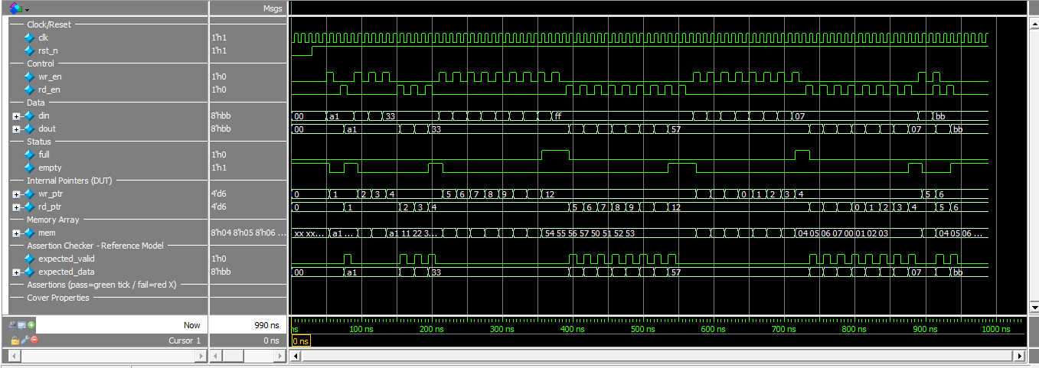

TRANSCRIPT:
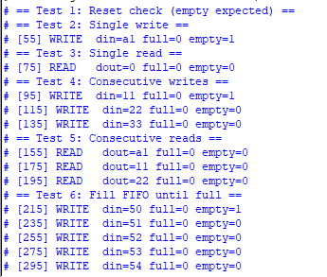
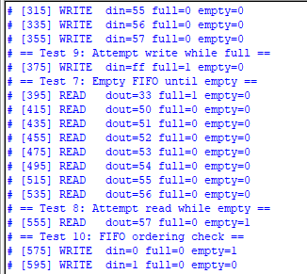
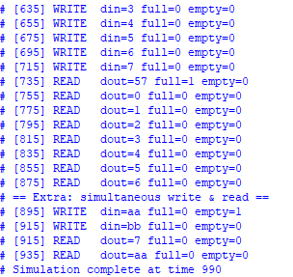

COMMAND:
vlib work
vmap work work
vlog -sv -mfcu -cuname bind_unit fifo.sv fifo_assertions.sv fifo_bind.sv fifo_tb.sv
vopt +acc=npr work.fifo_tb -o fifo_tb_opt
vsim -assertdebug work.fifo_tb_opt -do wave.do

